*Projeto CRUD de Clientes com ASP.NET e VB.NET em Camadas*

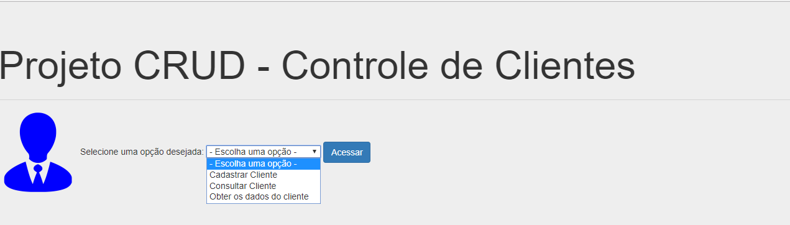

Default.aspx

<%@ Page Language="vb" AutoEventWireup="false" CodeBehind="Default.aspx.vb" Inherits="WebClientes._Default" %>

<!DOCTYPE html>

<html xmlns="http://www.w3.org/1999/xhtml">

<head runat="server">

<link href="Content/bootstrap.css" type="text/css" rel="stylesheet" />

<script src="Scripts/jquery-1.9.1.min.js"></script>

<script src="Scripts/bootstrap.min.js"></script>

<title>Home</title>

</head>

<body>

<form id="form1" runat="server">

<div class="jumbotron">

<h1>Projeto CRUD - Controle de Clientes</h1>

<hr />

<asp:Image ID="Image1" runat="server" ImageUrl="~/Image/user.png" />

Selecione uma opção desejada:

<asp:DropDownList runat="server" ID="ddlMenu">

<asp:ListItem Value="0" Text=" - Escolha uma opção - "></asp:ListItem>

<asp:ListItem Value="1" Text="Cadastrar Cliente"></asp:ListItem>

<asp:ListItem Value="2" Text="Consultar Cliente"></asp:ListItem>

<asp:ListItem Value="3" Text="Obter os dados do cliente"></asp:ListItem>

</asp:DropDownList>

<asp:Button runat="server" ID="btnAcessar" CssClass="btn btn-primary" Text="Acessar"

OnClick="btnAcessar_Click" />

<p>

<asp:Label runat="server" ID="lblMensagem" ForeColor="Red"></asp:Label>

</p>

</div>

</form>

</body>

</html>

Code Behind do Default.aspx

Public Class _Default

Inherits System.Web.UI.Page

Protected Sub Page_Load(ByVal sender As Object, ByVal e As System.EventArgs) Handles Me.Load

End Sub

Protected Sub btnAcessar_Click(sender As Object, e As EventArgs)

If (ddlMenu.SelectedValue() = "0") Then

lblMensagem.Text = "Por favor selecione uma opção válida"

ElseIf (ddlMenu.SelectedValue() = "1") Then

Response.Redirect("Cadastro.aspx")

ElseIf (ddlMenu.SelectedValue = "2") Then

Response.Redirect("Consulta.aspx")

ElseIf (ddlMenu.SelectedValue() = "3") Then

Response.Redirect("Detalhes.aspx")

End If

End Sub

End Class

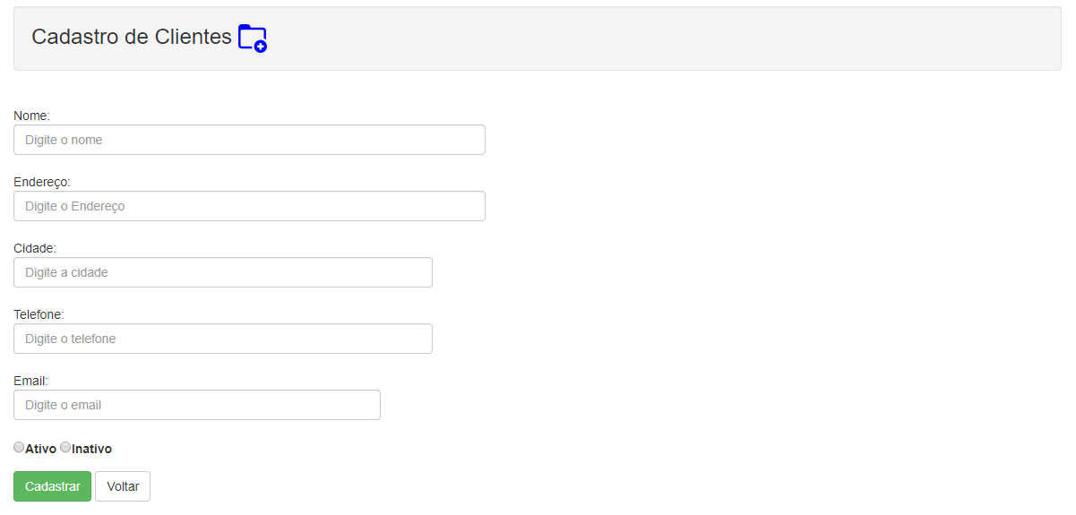

Cadastro.aspx

<%@ Page Language="vb" AutoEventWireup="false" CodeBehind="Cadastro.aspx.vb" Inherits="WebClientes.Cadastro" %>

<!DOCTYPE html>

<html xmlns="http://www.w3.org/1999/xhtml">

<head runat="server">

<link href="Content/bootstrap.css" rel="stylesheet" type="text/css" />

<script src="Scripts/bootstrap.min.js"></script>

<script src="Scripts/jquery-1.9.1.min.js"></script>

<title></title>

</head>

<body>

<form id="form1" runat="server">

<div class="container">

<div class="span10 offset1">

<div class="row">

<h3 class="well">Cadastro de Clientes <asp:Image ID="Image1" runat="server" ImageUrl="~/Image/add-folder-32.ico"/></h3>

<br />

Nome:<br />

<asp:TextBox ID="txtNome" runat="server" placeholder="Digite o nome" CssClass="form-control" Width="45%"></asp:TextBox>

<asp:RequiredFieldValidator

runat="server"

ControlToValidate="txtNome"

ErrorMessage = "Por favor digite o nome"

ForeColor="Red">

</asp:RequiredFieldValidator>

<br />

Endereço: <br />

<asp:TextBox ID="txtEndereco" runat="server" placeholder="Digite o Endereço" CssClass="form-control" Width="45%"></asp:TextBox>

<asp:RequiredFieldValidator

runat="server"

ControlToValidate="txtEndereco"

ErrorMessage ="Por favor digite o endereço"

ForeColor="Red">

</asp:RequiredFieldValidator>

<br />

Cidade: <br />

<asp:TextBox ID="txtCidade" runat="server" placeholder="Digite a cidade" CssClass="form-control" Width="40%"></asp:TextBox>

<asp:RequiredFieldValidator

runat="server"

ControlToValidate="txtCidade"

ErrorMessage = "Por favor digite a cidade"

ForeColor="Red"></asp:RequiredFieldValidator>

<br />

Telefone: <br />

<asp:TextBox ID="txtTelefone" runat="server" placeholder="Digite o telefone" CssClass="form-control" Width="40%"></asp:TextBox>

<asp:RequiredFieldValidator

runat="server"

ControlToValidate="txtTelefone"

ErrorMessage ="Por favor digite o telefone"

ForeColor="Red">

</asp:RequiredFieldValidator>

<br />

Email: <br />

<asp:TextBox ID="txtEmail" runat="server" placeholder="Digite o email" CssClass="form-control" Width="35%">

</asp:TextBox>

<asp:RequiredFieldValidator

runat="server"

ControlToValidate="txtEmail"

ErrorMessage = "Por favor digite o email"

ForeColor="Red">

</asp:RequiredFieldValidator>

<br />

<asp:RadioButton ID="rbtAtivo" runat="server" Text="Ativo" GroupName="ClienteGroup"/>

<asp:RadioButton ID="rbtInativo" runat="server" Text="Inativo" GroupName="ClienteGroup"/>

<p>

<asp:Label runat="server" ID="lblMensagem" ForeColor="Red"></asp:Label>

</p>

<asp:Button runat="server" ID="btnCadastrar" CssClass="btn btn-success" Text="Cadastrar" OnClick="btnCadastrar_Click" />

<a href="Default.aspx" class="btn btn-default">Voltar</a>

</div>

</div>

</div>

</form>

</body>

</html>

Code behind cadastro.aspx

Imports BLL

Imports DTO

Public Class Cadastro

Inherits System.Web.UI.Page

Protected Sub Page_Load(ByVal sender As Object, ByVal e As System.EventArgs) Handles Me.Load

End Sub

Protected Sub btnCadastrar_Click(sender As Object, e As EventArgs)

Try

Dim cod As Integer

Dim cliente As New ClientesDTO

cliente.Nome = txtNome.Text

cliente.Endereco = txtEndereco.Text

cliente.Cidade = txtCidade.Text

cliente.Email = txtEmail.Text

cliente.Telefone = txtTelefone.Text

If (rbtAtivo.Checked) Then

cliente.Ativo = True

Else

cliente.Ativo = False

End If

Dim clientesBLL As New ClientesBLL

cod = clientesBLL.Gravar(cliente)

If (cod > 0) Then

lblMensagem.Text = "Cliente " + cliente.Nome + " inserido com sucesso!"

txtCidade.Text = ""

txtEmail.Text = ""

txtEndereco.Text = ""

txtNome.Text = ""

txtTelefone.Text = ""

rbtAtivo.Checked = True

rbtInativo.Checked = False

End If

Catch ex As Exception

lblMensagem.Text = ex.Message

End Try

End Sub

End Class

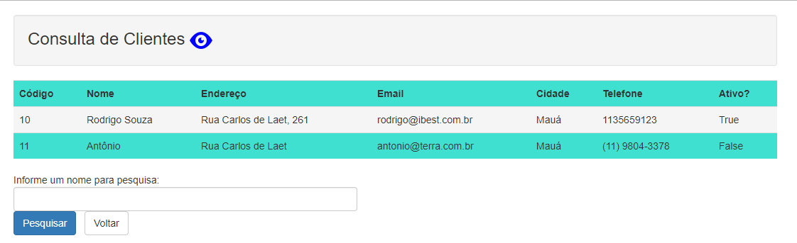

Código consulta.aspx

<%@ Page Language="vb" AutoEventWireup="false" CodeBehind="Consulta.aspx.vb" Inherits="WebClientes.Consulta" %>

<!DOCTYPE html>

<html xmlns="http://www.w3.org/1999/xhtml">

<head runat="server">

<link href="Content/bootstrap.css" rel="stylesheet" type="text/css" />

<script src="Scripts/bootstrap.min.js"></script>

<script src="Scripts/jquery-1.9.1.min.js"></script>

<title></title>

</head>

<body>

<form id="form1" runat="server">

<div class="container">

<div class="span10 col-lg-offset-1">

<div class="row">

<h3 class="well">Consulta de Clientes <asp:Image runat="server" ID="imgConsulta" ImageUrl="~/Image/Ver.ico" /></h3>

<asp:GridView runat="server" ID="grvClientes" CssClass="table table-hover"

GridLines="None" AutoGenerateColumns="false" BackColor="Turquoise">

<Columns>

<asp:BoundField HeaderText="Código" DataField="idCliente" />

<asp:BoundField HeaderText="Nome" DataField="Nome" />

<asp:BoundField HeaderText="Endereço" DataField="Endereco" />

<asp:BoundField HeaderText="Email" DataField="Email" />

<asp:BoundField HeaderText="Cidade" DataField="Cidade" />

<asp:BoundField HeaderText="Telefone" DataField="Telefone" />

<asp:BoundField HeaderText="Ativo?" DataField="Ativo" />

</Columns>

<RowStyle CssClass="cursor-pointer" />

</asp:GridView>

<p>

<asp:Label ID="lblMensagem" runat="server" ForeColor="Red"></asp:Label>

</p>

<p>

Informe um nome para pesquisa:

<asp:TextBox runat="server" ID="txtNomePesquisa" CssClass="form-control" Width="45%"></asp:TextBox>

<asp:Button runat="server" ID="btnPesquisar" Text="Pesquisar" CssClass="btn btn-primary" OnClick="btnPesquisar_Click"/> &nbsp

<a href="Default.aspx" class="btn btn-default">Voltar</a>

</p>

</div>

</div>

</div>

</form>

</body>

</html>

Code behind de consulta.aspx

Imports BLL

Public Class Consulta

Inherits System.Web.UI.Page

Protected Sub Page_Load(ByVal sender As Object, ByVal e As System.EventArgs) Handles Me.Load

Try

Dim clienteBLL As New ClientesBLL

grvClientes.DataSource = clienteBLL.ListarTodos()

grvClientes.DataBind()

Catch ex As Exception

lblMensagem.Text = ex.Message

End Try

End Sub

Protected Sub btnPesquisar_Click(sender As Object, e As EventArgs)

Try

Dim clientePesqBLL As New ClientesBLL

Dim strNome As String

strNome = txtNomePesquisa.Text

lblMensagem.Text = String.Empty

grvClientes.DataSource = clientePesqBLL.PesquisarPorNome(strNome)

grvClientes.DataBind()

If (grvClientes.Rows.Count = 0) Then

lblMensagem.Text = "Nenhum cliente foi encontrado com a pesquisa informada!!"

lblMensagem.ForeColor = Drawing.Color.Blue

End If

Catch ex As Exception

lblMensagem.Text = ex.Message

End Try

End Sub

End Class

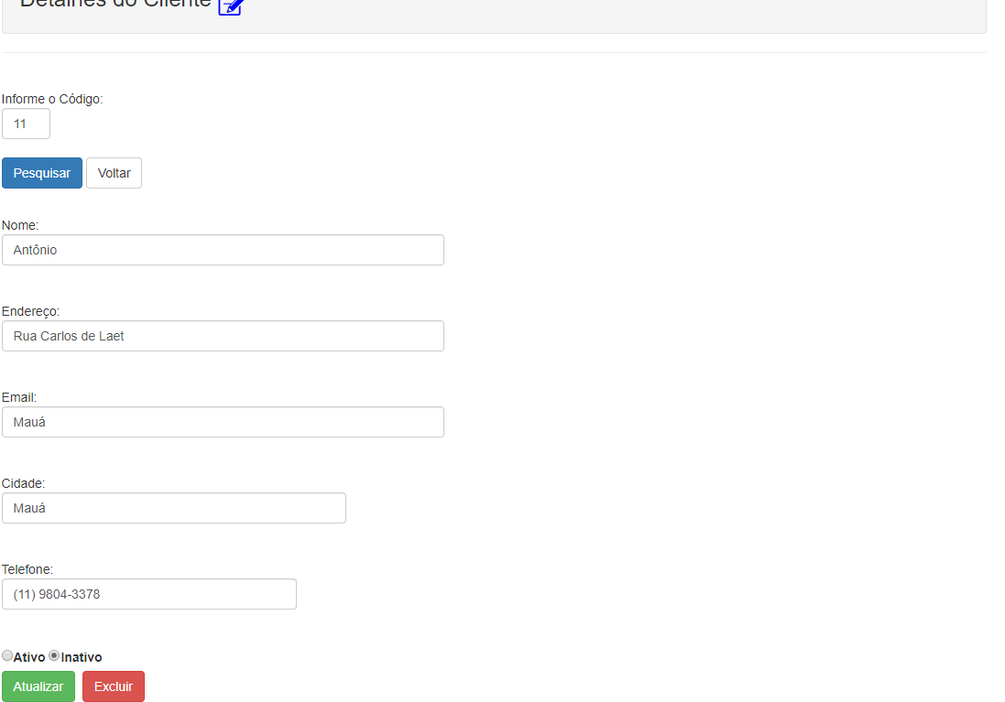

Detalhes.aspx

<%@ Page Language="vb" AutoEventWireup="false" CodeBehind="Detalhes.aspx.vb" Inherits="WebClientes.Detalhes" %>

<!DOCTYPE html>

<html xmlns="http://www.w3.org/1999/xhtml">

<head runat="server">

<link href="Content/bootstrap.css" rel="stylesheet" type="text/css" />

<script src="Scripts/bootstrap.min.js"></script>

<script src="Scripts/jquery-1.9.1.min.js"></script>

<title></title>

</head>

<body>

<form id="form1" runat="server">

<div class="container">

<div class="col-lg-offset-1">

<div class="row">

<h3 class="well">Detalhes do Cliente <asp:Image runat="server" ID="imgDetalhes" ImageUrl="~/Image/edit-11-32.ico" /></h3>

<hr />

<br />

Informe o Código:<br />

<asp:TextBox ID="txtCodigo" runat="server" CssClass="form-control" Width="5%"></asp:TextBox>

<br />

<asp:Button ID="btnPesquisa" runat="server" CssClass="btn btn-primary" Text="Pesquisar" OnClick="btnPesquisa_Click" />

<a href="Default.aspx" class="btn btn-default">Voltar</a>

<br /><br />

<p>

<asp:Label ID="lblMensagem" runat="server" ForeColor="Red"></asp:Label>

</p>

<asp:Panel ID="pnlDados" runat="server">

Nome:<br />

<asp:TextBox ID="txtNome" CssClass="form-control" runat="server" Width="45%"></asp:TextBox>

<br /><br />

Endereço:<br />

<asp:TextBox ID="txtEndereco" CssClass="form-control" runat="server" Width="45%"></asp:TextBox>

<br /><br />

Email:<br />

<asp:TextBox ID="txtEmail" CssClass="form-control" runat="server" Width="45%"></asp:TextBox>

<br /><br />

Cidade:<br />

<asp:TextBox ID="txtCidade" CssClass="form-control" runat="server" Width="35%"></asp:TextBox>

<br /><br />

Telefone:<br />

<asp:TextBox ID="txtTelefone" CssClass="form-control" runat="server" Width="30%"></asp:TextBox>

<br /><br />

<asp:RadioButton ID="rbtAtivo" Text="Ativo" runat="server" GroupName="ClienteGroup"/>

<asp:RadioButton ID="rbtInativo" Text="Inativo" runat="server" GroupName="ClienteGroup"/>

<br />

<asp:Button ID="btnAtualizar" Text="Atualizar" CssClass="btn btn-success" runat="server" />&nbsp

<asp:Button ID="btnExcluir" Text="Excluir" CssClass="btn btn-danger" runat="server" />

</asp:Panel>

</div>

</div>

</div>

</form>

</body>

</html>

Code behind detalhes.aspx

Imports BLL

Imports DTO

Public Class Detalhes

Inherits System.Web.UI.Page

Protected Sub Page_Load(ByVal sender As Object, ByVal e As System.EventArgs) Handles Me.Load

pnlDados.Visible = False

End Sub

Protected Sub btnPesquisa_Click(sender As Object, e As EventArgs) Handles btnPesquisa.Click

Try

Dim cod As Integer

cod = Integer.Parse(txtCodigo.Text)

Dim clientesBLL As New ClientesBLL

Dim clientes As New ClientesDTO

clientes = clientesBLL.PesquisarPorCodigo(cod)

If (Not clientes Is Nothing) Then

pnlDados.Visible = True

txtNome.Text = clientes.Nome

txtEndereco.Text = clientes.Endereco

txtEmail.Text = clientes.Cidade

txtCidade.Text = clientes.Cidade

txtTelefone.Text = clientes.Telefone

If clientes.Ativo = True Then

rbtAtivo.Checked = True

Else

rbtInativo.Checked = True

End If

Else

pnlDados.Visible = False

lblMensagem.Text = "Cliente não localizado"

txtCodigo.Text = String.Empty

End If

Catch ex As Exception

lblMensagem.Text = ex.Message

End Try

End Sub

Protected Sub btnAtualizar_Click(sender As Object, e As EventArgs) Handles btnAtualizar.Click

Try

Dim clientes As New ClientesDTO

clientes.IdCliente = Integer.Parse(txtCodigo.Text)

clientes.Nome = txtNome.Text

clientes.Endereco = txtEndereco.Text

clientes.Email = txtEmail.Text

clientes.Cidade = txtCidade.Text

clientes.Telefone = txtTelefone.Text

If rbtAtivo.Checked Then

clientes.Ativo = True

Else

clientes.Ativo = False

End If

Dim clientesBLL As New ClientesBLL

Dim result As Integer

result = clientesBLL.Atualizar(clientes)

If (result > 0) Then

lblMensagem.Text = "Cliente alterado com sucesso!!"

txtNome.Text = ""

txtEndereco.Text = ""

txtEmail.Text = ""

txtCidade.Text = ""

txtTelefone.Text = ""

rbtAtivo.Checked = True

rbtInativo.Checked = False

End If

Catch ex As Exception

lblMensagem.Text = ex.Message

End Try

End Sub

Protected Sub btnExcluir_Click(sender As Object, e As EventArgs) Handles btnExcluir.Click

Try

Dim cod, result As Integer

Dim clientesBLL As New ClientesBLL

cod = Integer.Parse(txtCodigo.Text)

result = clientesBLL.Excluir(cod)

If (result > 0) Then

lblMensagem.Text = "Exclusão efetuada com sucesso!!"

txtNome.Text = ""

txtEndereco.Text = ""

txtEmail.Text = ""

txtCidade.Text = ""

txtTelefone.Text = ""

rbtAtivo.Checked = True

rbtInativo.Checked = False

End If

Catch ex As Exception

lblMensagem.Text = ex.Message

End Try

End Sub

End Class

Camada de Dados (Conexao.vb)

Imports System.Data.SqlClient

Public Class Conexao

Protected con As SqlConnection

Protected cmd As SqlCommand

Protected dr As SqlDataReader

Protected Sub AbrirConexao()

Try

con = New SqlConnection("Data Source=NOTE;Initial Catalog=CRUD;Integrated Security=true")

con.Open()

Catch ex As Exception

Throw New Exception(ex.Message)

End Try

End Sub

Protected Sub FecharConexao()

Try

If (con.State = ConnectionState.Open) Then

con.Close()

End If

Catch ex As Exception

Throw New Exception(ex.Message)

End Try

End Sub

End Class

Camada de Dados (ClienteDAL.vb)

Imports System.Data.SqlClient

Imports DTO

Public Class ClientesDAL

Inherits Conexao

Public Function Gravar(ByVal cliente As ClientesDTO) As Integer

Try

AbrirConexao()

cmd = New SqlCommand("INSERT INTO Clientes(Nome,Endereco,Cidade,Telefone,Email,Ativo) VALUES(@Nome,@Endereco,@Cidade,@Telefone,@Email,@Ativo)")

cmd.Connection = con

cmd.Parameters.AddWithValue("@Nome", cliente.Nome)

cmd.Parameters.AddWithValue("@Endereco", cliente.Endereco)

cmd.Parameters.AddWithValue("@Cidade", cliente.Cidade)

cmd.Parameters.AddWithValue("@Telefone", cliente.Telefone)

cmd.Parameters.AddWithValue("@Email", cliente.Email)

cmd.Parameters.AddWithValue("@Ativo", cliente.Ativo)

Return cmd.ExecuteNonQuery()

Catch ex As Exception

Throw New Exception(ex.Message)

Finally

FecharConexao()

End Try

End Function

Public Function Atualizar(ByVal cliente As ClientesDTO) As Integer

Dim strSQL = ""

Try

AbrirConexao()

strSQL = "UPDATE Clientes SET Nome = @Nome," &

"Endereco = @Endereco," &

"Cidade = @Cidade," &

"Telefone = @Telefone," &

"Email = @Email," &

"Ativo = @Ativo " &

" WHERE IdCliente = @IdCliente"

cmd = New SqlCommand(strSQL)

cmd.Connection = con

cmd.Parameters.AddWithValue("@IdCliente", cliente.IdCliente)

cmd.Parameters.AddWithValue("@Nome", cliente.Nome)

cmd.Parameters.AddWithValue("@Endereco", cliente.Endereco)

cmd.Parameters.AddWithValue("@Cidade", cliente.Cidade)

cmd.Parameters.AddWithValue("@Telefone", cliente.Telefone)

cmd.Parameters.AddWithValue("@Email", cliente.Email)

cmd.Parameters.AddWithValue("@Ativo", cliente.Ativo)

Return cmd.ExecuteNonQuery()

Catch ex As Exception

Throw New Exception(ex.Message)

Finally

FecharConexao()

End Try

End Function

Public Function Excluir(ByVal id As Integer) As Integer

Try

AbrirConexao()

cmd = New SqlCommand("DELETE FROM Clientes WHERE IdCliente = @IdCliente")

cmd.Connection = con

cmd.Parameters.AddWithValue("@IdCliente", id)

Return cmd.ExecuteNonQuery()

Catch ex As Exception

Throw New Exception(ex.Message)

Finally

FecharConexao()

End Try

End Function

Public Function PesquisarPorCodigo(ByVal id As Integer) As ClientesDTO

Try

AbrirConexao()

cmd = New SqlCommand("SELECT * FROM Clientes WHERE IdCliente = @IdCliente")

cmd.Connection = con

cmd.CommandType = CommandType.Text

cmd.Parameters.AddWithValue("@IdCliente", id)

dr = cmd.ExecuteReader()

Dim clientes As ClientesDTO = Nothing

If (dr.Read()) Then

clientes = New ClientesDTO

clientes.IdCliente = Convert.ToInt32(dr("IdCliente"))

clientes.Nome = Convert.ToString(dr("Nome"))

clientes.Endereco = Convert.ToString(dr("Endereco"))

clientes.Email = Convert.ToString(dr("Email"))

clientes.Cidade = Convert.ToString(dr("Cidade"))

clientes.Telefone = Convert.ToString(dr("Telefone"))

clientes.Ativo = dr("Ativo")

End If

dr.Close()

Return clientes

Catch ex As Exception

Throw New Exception(ex.Message)

Finally

FecharConexao()

End Try

End Function

Public Function ListarTodos() As List(Of ClientesDTO)

Try

AbrirConexao()

cmd = New SqlCommand("SELECT * FROM Clientes")

cmd.Connection = con

dr = cmd.ExecuteReader()

Dim lista As New List(Of ClientesDTO)

While (dr.Read())

Dim clientes As New ClientesDTO

clientes.IdCliente = Convert.ToInt32(dr("IdCliente"))

clientes.Nome = Convert.ToString(dr("Nome"))

clientes.Endereco = Convert.ToString(dr("Endereco"))

clientes.Email = Convert.ToString(dr("Email"))

clientes.Cidade = Convert.ToString(dr("Cidade"))

clientes.Telefone = Convert.ToString(dr("Telefone"))

clientes.Ativo = dr("Ativo")

lista.Add(clientes)

End While

dr.Close()

Return lista

Catch ex As Exception

Throw New Exception(ex.Message)

Finally

FecharConexao()

End Try

End Function

'Extra: Pesquisar por nome (com Like)

'###################################################################

Public Function PesquisarPorNome(ByVal nome As String) As List(Of ClientesDTO)

Try

Dim lista As New List(Of ClientesDTO)

AbrirConexao()

cmd = New SqlCommand("SELECT * FROM Clientes WHERE Nome LIKE '%" + nome + "%'")

cmd.Connection = con

cmd.CommandType = CommandType.Text

dr = cmd.ExecuteReader()

While (dr.Read())

Dim cliente As New ClientesDTO

cliente.Nome = Convert.ToString(dr("Nome"))

cliente.Endereco = Convert.ToString(dr("Endereco"))

cliente.Email = Convert.ToString(dr("Email"))

cliente.Cidade = Convert.ToString(dr("Cidade"))

cliente.Telefone = Convert.ToString(dr("Telefone"))

cliente.IdCliente = Convert.ToInt32(dr("IdCliente"))

cliente.Ativo = dr("Ativo")

lista.Add(cliente)

End While

dr.Close()

Return lista

Catch ex As Exception

Throw New Exception(ex.Message)

Finally

FecharConexao()

End Try

End Function

End Class

Camada de Transferência (ClientesDTO.vb)

Public Class ClientesDTO

Private _idCliente As Integer

Private _nome As String

Private _endereco As String

Private _cidade As String

Private _telefone As String

Private _email As String

Private _ativo As Boolean

Public Property IdCliente As Integer

Get

Return _idCliente

End Get

Set(value As Integer)

_idCliente = value

End Set

End Property

Public Property Nome As String

Get

Return _nome

End Get

Set(value As String)

_nome = value

End Set

End Property

Public Property Endereco As String

Get

Return _endereco

End Get

Set(value As String)

_endereco = value

End Set

End Property

Public Property Cidade As String

Get

Return _cidade

End Get

Set(value As String)

_cidade = value

End Set

End Property

Public Property Telefone As String

Get

Return _telefone

End Get

Set(value As String)

_telefone = value

End Set

End Property

Public Property Email As String

Get

Return _email

End Get

Set(value As String)

_email = value

End Set

End Property

Public Property Ativo As Boolean

Get

Return _ativo

End Get

Set(value As Boolean)

_ativo = value

End Set

End Property

End Class

Camada de Negócios (ClientesBLL.vb)

Imports DAL

Imports DTO

Public Class ClientesBLL

Public Function Gravar(ByVal cliente As ClientesDTO) As Integer

Dim db As New ClientesDAL

Dim cod As Integer

Try

cod = db.Gravar(cliente)

Return cod

Catch ex As Exception

Throw New Exception(ex.Message)

End Try

End Function

Public Function Atualizar(ByVal cliente As ClientesDTO) As Integer

Dim db As New ClientesDAL

Dim cod As Integer

Try

cod = db.Atualizar(cliente)

Return cod

Catch ex As Exception

Throw New Exception(ex.Message)

End Try

End Function

Public Function Excluir(ByVal id As Integer) As Integer

Dim db As New ClientesDAL

Dim cod As Integer

Try

cod = db.Excluir(id)

Return cod

Catch ex As Exception

Throw New Exception(ex.Message)

End Try

End Function

Public Function PesquisarPorCodigo(ByVal id As Integer) As ClientesDTO

Dim db As New ClientesDAL

Dim cliente As New ClientesDTO

Try

cliente = db.PesquisarPorCodigo(id)

Return cliente

Catch ex As Exception

Throw New Exception(ex.Message)

End Try

End Function

Public Function ListarTodos() As List(Of ClientesDTO)

Dim db As New ClientesDAL

Dim lista As List(Of ClientesDTO)

Try

lista = db.ListarTodos()

Return lista

Catch ex As Exception

Throw New Exception(ex.Message)

End Try

End Function

Public Function PesquisarPorNome(ByVal nome As String) As List(Of ClientesDTO)

Dim db As New ClientesDAL

Dim lista As List(Of ClientesDTO)

Try

lista = db.PesquisarPorNome(nome)

Return lista

Catch ex As Exception

Throw New Exception(ex.Message)

End Try

End Function

End Class

**Web.Config**

<!-- Referência ao JQuery (Validações na tela de Cadastro -->

<appSettings>

<add key="ValidationSettings:UnobtrusiveValidationMode" value="None"/>

</appSettings>

**Nota: No Nuget Package instalar o bootstrap que carregará também funções JQuery**

